

**Lab Goal :** This lab was designed to teach you how to use broadcasting in Scratch to enable two sprites to chat.

**Lab Description :** Write a program in Scratch that will enable two sprites to chat. When one sprite is clicked, it will send a message to the other sprite. The receiving sprite will acknowledge that it received the message and the sending sprite will acknowledge that it sent the message.

**Step One ::** Go to the control / event section and select the *when sprite is clicked* control. Place this in the scripts section of the bug. Go to the looks section and select the *say X for Y seconds*. Add this to the *when sprite is clicked* control. Change it to say *bug_transmitting* for *2* seconds. Go to the control / event section and select the broadcast control. Add this to the *when sprite is clicked* control. Change it to *broadcast robot_talk*. Go to the control / event section and select the *when I receive* control. Add this to the scripts section of the bug. Go to the looks section and select the *say X for Y seconds*. Add this to the *when I receive* control. Change it to say *bug_receiving* for *2* seconds.

**Step Two ::** Do the same thing for the robot.

**Ouptut : (after clicking on the bug )**

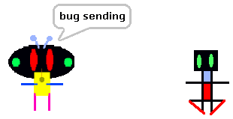

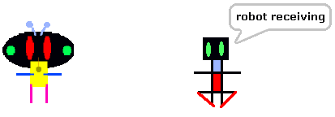

**Ouptut : (after clicking on the robot )**

